Enterprise Retail Analytics Platform on Azure

1. Project Overview
This project is an end-to-end Azure Data Engineering solution designed to ingest, process, and curate retail data. The platform ingests daily sales transactions, product master files, customer data, and currency exchange rates, centralizing them for business intelligence reporting. The data processing engine is built on Azure Databricks utilizing a strict Medallion Architecture (Bronze, Silver, Gold). Orchestrated entirely by Azure Data Factory (ADF), the pipeline moves raw data through transformation layers, loads the curated data into an Azure SQL Database, and automatically triggers Power BI dashboard refreshes to deliver real-time, visualized business insights.

2. Source System Configurations
The platform successfully ingests and standardizes four distinct operational systems:
- Orders (Daily CSV): A daily delta file containing sales transactions. Ingested with a partition key on OrderDate.
- Products (Weekly CSV): A weekly full catalog master refresh.
- Customers (Azure SQL): Incremental watermark-based load utilizing the LastUpdated timestamp from an operational RDBMS.
- Exchange Rates (REST API): A semi-structured hierarchical JSON payload fetched daily via an HTTP GET request.

3. Architecture Diagram

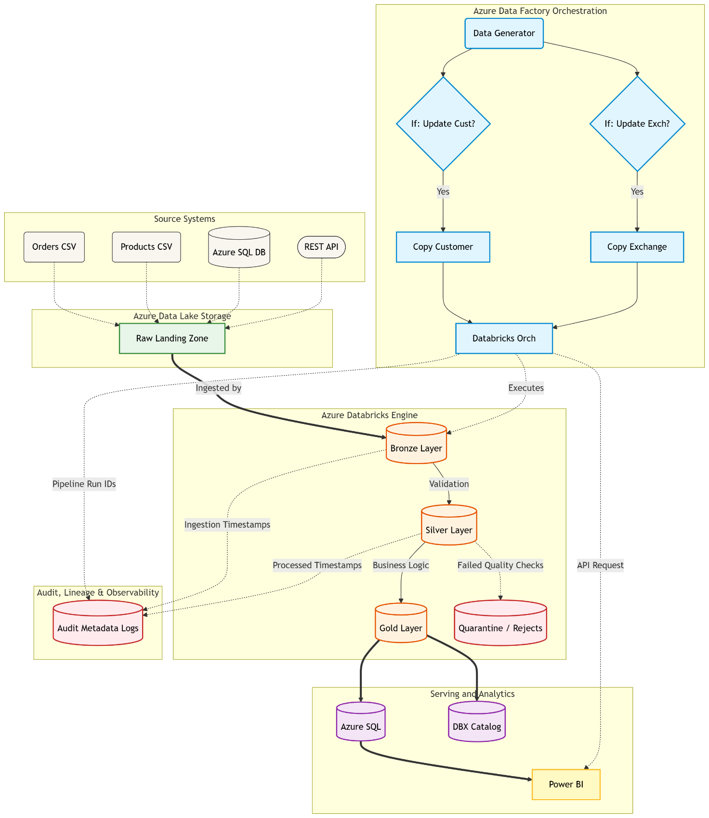

4. Medallion Pipeline Implementation
The data transformation is executed via an automated Databricks pipeline moving data from raw physical landing zones to logical business views.

4.1 The Bronze Layer (Raw Ingestion)
The Bronze layer acts as the immutable historical ledger of all incoming data.
- Schema-on-Read Stability: Order and Product CSVs are ingested into Delta Lake with all columns typed as STRING to prevent upstream schema changes from breaking the ingestion pipeline.
- Native JSON Storage: The complex Exchange Rates payload is stored natively as a raw JSON string.
- Idempotency: Ingestion is tracked via a file registry to ensure data is never double-counted upon reruns.

4.2 The Silver Layer (Validation & Conformance)
The Silver layer cleans, types, and standardizes the data for analytical processing.
- Dynamic Schema Evolution: Automatically detects and applies new columns using ALTER TABLE ADD COLUMNS.
- JSON Flattening: Parses and flattens the nested Exchange Rates JSON string into tabular columns.
- Slowly Changing Dimensions (SCD Type 2): Processes the Customer table to preserve historical states (e.g., tracking a customer's change of residence).
- Data Quality Routing: Validates constraints (e.g., positive quantities, valid foreign keys). Failing rows are not dropped; they are flagged with _IsRejected and routed to a quarantine table.

4.3 The Gold Layer (Business Intelligence)
The Gold layer curates the cleaned data into high-performance models for downstream consumption.
- Star Schema: Builds master dimension tables (dim_customer, dim_product, dim_date) and a core fact table (fact_sales).
- Point-in-Time Accuracy: Sales facts are joined to the Customer dimension based on the exact SCD2 historical version active on the date of purchase.
- Aggregations: Pre-calculates base-currency revenue and margin aggregates for immediate dashboard rendering.

5. Serving Layer & Visualization
Once the data reaches the Gold layer, it is prepared for business consumption and reporting.
- Azure SQL Database Integration: The highly aggregated and curated Gold layer data is written directly to an Azure SQL Database, providing a highly responsive serving layer for BI tools.
- Databricks Catalog Backup: A duplicate backup of the Gold layer tables is retained securely within the Databricks Catalog, ensuring fault tolerance and allowing ad-hoc data science queries directly against the lakehouse.
- Power BI Dashboards: Power BI is connected directly to the Azure SQL Database to generate rich, interactive visualizations. This dashboard provides stakeholders with immediate insights into sales trends, customer behavior, and margin calculations.

6. Orchestration: Azure Data Factory (ADF) Pipelines
The entire end-to-end workflow is orchestrated using Azure Data Factory. The architecture relies on a master pipeline that triggers several modular sub-pipelines based on logical conditions.

Sub-Pipelines
- Exchange Rate API Pipeline: Makes an HTTP request to the external REST API and copies the daily exchange rate JSON payload into the raw storage zone.
- Customer Data Copy Pipeline: Connects to the source Azure SQL database, fetches raw customer data, and copies it to the raw/customers directory in Azure Data Lake Storage (ADLS).
- Databricks Orchestrator Pipeline: * Executes a Databricks Orchestrator Notebook parameterized to run in "Bronze to Gold" mode.
  - Captures the successful completion output of the notebook.
  - Uses a Web Activity to send a REST API request directly to the Power BI Service, triggering an automatic dataset refresh so the dashboard reflects the newly processed data immediately.

The Master Pipeline
The Master Pipeline acts as the primary controller for the daily batch run:
- Data Generation: Executes the data generator code in incremental mode to simulate/produce the latest daily delta records.
- Condition Checks (If Activity): Evaluates if new data needs to be pulled. If the condition is met, it triggers the Exchange Rate API Pipeline and the Customer Data Copy Pipeline.
- Execution & BI Refresh: Once the raw data is successfully landed, it triggers the Databricks Orchestrator Pipeline, which drives the data through the Medallion architecture (Bronze -> Silver -> Gold) and successfully refreshes the Power BI dashboard.

7. Quality Assurance & Testing
To ensure the reliability and accuracy of the data transformations, Unit Test Cases have been developed and integrated into the workflow. These tests validate complex transformation logic (like SCD Type 2 changes and JSON flattening) and ensure that data quality constraints in the Silver layer operate exactly as intended before the code is promoted to production.

8. Audit, Lineage, and Monitoring
To ensure enterprise-grade observability and error handling, specific technical metadata columns are appended during processing:
- _AdfPipelineRunId: Mapped to every row in Bronze and Silver to link data back to the exact ADF pipeline run.
- _IngestionTimestamp: Tracks the physical landing time in Bronze.
- _ProcessedTimestamp: Tracks the execution time of Databricks transformations in Silver.

